Idaho Housing and Finance Association
Goods and Services Selection Point Submission Form

Developments located within the stated distances from goods, services, or major employer are eligible for 0.5 selection criteria points per category for a maximum of 5.0 points.
Please use this form to indicate whether selection criteria points are being claimed for a particular category and document how the points are justified. Third party mileage documentation must be used to justify points (Google Maps, market study information, etc.) that is to be measured from the project address indicated in the application or the nearest address or intersection within 100 feet should no project address be available yet to the address of the Good or Service. For each category, please list the Good or Service name (i.e. business name), and insert the documentation (screenshots are acceptable) or list the page in the market study where the information can be found.
Please note, the Association reserves the right to reject proposed Goods or Services founds to be, in the Association’s sole discretion, inadequate (e.g. entities that are no longer in business or only operate a part of the year). It is recommended to contact the Association regarding any questions on Goods and Services eligibility prior to application.
A single “entity” may be used for multiple categories in which the building/address houses multiple businesses or such business offers multiple services (e.g. grocery stores with a full service bank branch inside would qualify for grocery store and bank categories, super centers that include groceries and electronics or clothing would qualify for grocery store and retail shopping categories, etc.).

Definitions:
Good and Services – located within 1.5 miles driving distance in urban communities or 3.0 miles driving distance in rural communities.
Major Employer – located within 5.0 miles driving distance in urban communities or 10.0 miles driving distance in rural communities.
Urban Communities – communities that do not qualify as eligible communities for USDA RD programs
Rural Communities – communities that qualify as eligible communities for USDA RD Multifamily Housing programs

EXAMPLE
Please use the following example, which uses the main IHFA building as the “project” address, to present the information in this form.
1. Full service Grocery Store (does not include convenience stores).
Claiming points? (Y/N) | Yes
If yes, please answer the following.
Entity Name | Albertson
Entity Address | 1219 S Broadway Ave, Boise ID
Distance from Project? | 1.3 miles
Page in Market Study or Insert Documentation Below

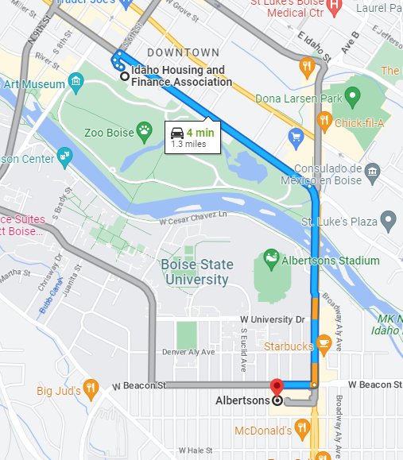

1. Full service Grocery Store (does not include convenience stores).
Claiming points? (Y/N)
If yes, please answer the following.
Entity Name
Entity Address
Distance from Project?
Page in Market Study or Insert Documentation Below

2. Retail Shopping (i.e., hardware, clothing store, etc.)
Claiming points? (Y/N)
If yes, please answer the following.
Entity Name
Entity Address
Distance from Project?
Page in Market Study or Insert Documentation Below

3. Police or Fire Station
Claiming points? (Y/N)
If yes, please answer the following.
Entity Name
Entity Address
Distance from Project?
Page in Market Study or Insert Documentation Below

4. Pharmacy
Claiming points? (Y/N)
If yes, please answer the following.
Entity Name
Entity Address
Distance from Project?
Page in Market Study or Insert Documentation Below

5. Post Office
Claiming points? (Y/N)
If yes, please answer the following.
Entity Name
Entity Address
Distance from Project?
Page in Market Study or Insert Documentation Below

6. Bank/Credit Union
Claiming points? (Y/N)
If yes, please answer the following.
Entity Name
Entity Address
Distance from Project?
Page in Market Study or Insert Documentation Below

7. Public Park
Claiming points? (Y/N)
If yes, please answer the following.
Entity Name
Entity Address
Distance from Project?
Page in Market Study or Insert Documentation Below

8. Education Facility (includes K-12 schools, university, adult education, vocational school, community college)
Claiming points? (Y/N)
If yes, please answer the following.
Entity Name
Entity Address
Distance from Project?
Page in Market Study or Insert Documentation Below

9. Public Library
Claiming points? (Y/N)
If yes, please answer the following.
Entity Name
Entity Address
Distance from Project?
Page in Market Study or Insert Documentation Below

10. Health Club or Recreational Center (i.e. YMCA, etc.)
Claiming points? (Y/N)
If yes, please answer the following.
Entity Name
Entity Address
Distance from Project?
Page in Market Study or Insert Documentation Below

11. Hospital or Medical Clinic, Medical or Dental Office
Claiming points? (Y/N)
If yes, please answer the following.
Entity Name
Entity Address
Distance from Project?
Page in Market Study or Insert Documentation Below

12. Social Services Center (i.e., Senior Citizen Center or Community Center) or Licensed Childcare Facility
Claiming points? (Y/N)
If yes, please answer the following.
Entity Name
Entity Address
Distance from Project?
Page in Market Study or Insert Documentation Below

13. Bus stop, transit stop (i.e., Park & Ride, etc.)
Claiming points? (Y/N)
If yes, please answer the following.
Entity Name
Entity Address
Distance from Project?
Page in Market Study or Insert Documentation Below

14. Public greenbelt bike/walking path access (does not include city sidewalks or street bike lanes)
Claiming points? (Y/N)
If yes, please answer the following.
Entity Name
Entity Address
Distance from Project?
Page in Market Study or Insert Documentation Below

15. Major Employer (as documented in the Market Study or Appraisal)
Claiming points? (Y/N)
If yes, please answer the following.
Entity Name
Entity Address
Distance from Project?
Page in Market Study or Insert Documentation Below

